Bangladesh Medical Association (BMA)
List of Life Member-181
07. BMA Brahmanbaria Branch

Sl No | Voter No | Voter Details
1 | Voter No  LM-0700001  No Image | DR. MD. FARIDUL HUDA  F/Name:  M/Name:  BM & DC Reg. No:  NID:  Cell:  Address:  Blood Group:  E X P I R E D
2 | Voter No  LM-0700002  No Image | DR. ABDUL KADIR  F/Name:  M/Name:  BM & DC Reg. No:  NID:  Cell:  Address: Niramoy Clinic,Haldar Para Road, Brahmanbaria  Blood Group:  E X P I R E D
3 | Voter No  LM-0700003  No Image | DR. MD. MASOODUR RAHMAN  F/Name:  M/Name:  BM & DC Reg. No:  NID:  Cell:  Address:  Blood Group:  E X P I R E D
4 | Voter No  LM-0700004  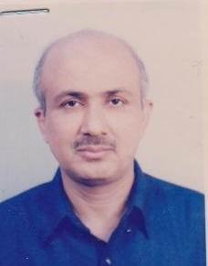 | DR. MD. FAKHRUZZAMAN BHUIYAN  F/Name:  M/Name:  BM & DC Reg. No:  NID:  Cell:  Address: Gokarna Road Kazi Para Brahmanbaria  Blood Group:
5 | Voter No  LM-0700005  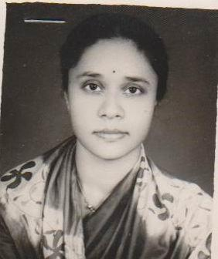 | DR. SULTANA ZAMAN  F/Name:  M/Name:  BM & DC Reg. No:  NID:  Cell:  Address: Gokarna Road Kazi Para Brahmanbaria  Blood Group:
6 | Voter No  LM-0700006  No Image | DR. SUKHENDU BIKASH TALUKDER  F/Name:  M/Name:  BM & DC Reg. No:  NID:  Cell:  Address: 136, Ramkanai School Road Paikpara Brahmanbaria  Blood Group:
7 | Voter No  LM-0700007  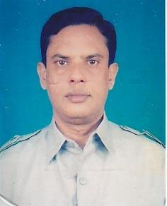 | DR. MD. AKHTAR HOSSAIN  F/Name:  M/Name:  BM & DC Reg. No:  NID:  Cell:  Address: TH & FPO Thana Health Complex, Sarail Brahmanbaria  Blood Group:
8 | Voter No  LM-0700008  No Image | DR. SWAPAN KUMAR BHOWMIK ROY  F/Name:  M/Name:  BM & DC Reg. No:  NID:  Cell:  Address: Jr. Consultant Eye Dept. Sadar Hospital Brahmanbaria  Blood Group:
9 | Voter No  LM-0700009  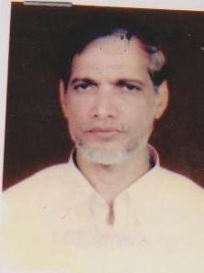 | DR. FARID UDDIN AHMED  F/Name:  M/Name:  BM & DC Reg. No:  NID:  Cell:  Address: The Model Clinic Halderpara Brahmanbaria  Blood Group:
10 | Voter No  LM-0700010  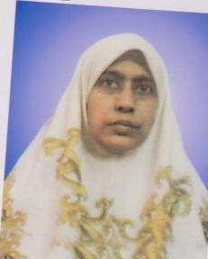 | DR. ASMA KHANAM  F/Name:  M/Name:  BM & DC Reg. No:  NID:  Cell:  Address: The Model Clinic Halderpara Brahmanbaria  Blood Group:
11 | Voter No  LM-0700011 | DR. MD. BAZLUR RAHMAN  F/Name:  M/Name:  BM & DC Reg. No:  NID:  Cell:  Address: West Paikpara Brahmanbaria  Blood Group:
12 | Voter No  LM-0700012  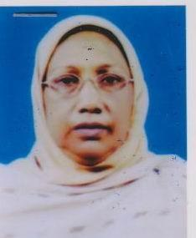 | DR. KHALEDA AKHTAR  F/Name:  M/Name:  BM & DC Reg. No:  NID:  Cell:  Address: West Paikpara Brahmanbaria  Blood Group:
13 | Voter No  LM-0700013  No Image | DR. HABIBUR RAHMAN  F/Name:  M/Name:  BM & DC Reg. No:  NID:  Cell:  Address: Khalek Manzil Moulovipara Brahmanbaria  Blood Group:
14 | Voter No  LM-0700014  No Image | DR. MESBAH UDDIN CHOWDHURY  F/Name:  M/Name:  BM & DC Reg. No:  NID:  Cell:  Address: Sadar Hospital Brahmanbaria  Blood Group:
15 | Voter No  LM-0700015 | DR. MD. ABU HANIF  F/Name:  M/Name:  BM & DC Reg. No:  NID:  Cell:  Address: Radiologist Sadar Hospital Brahmanbaria  Blood Group:
16 | Voter No  LM-0700016  No Image | DR. MAHMUD HOSSAIN FARUQUEE  F/Name:  M/Name:  BM & DC Reg. No:  NID:  Cell:  Address: Bangladesh Gas Fields Co. Ltd. Court Road Brahmanbaria  Blood Group:
17 | Voter No  LM-0700017  No Image | DR. ABDUR RASUL  F/Name:  M/Name:  BM & DC Reg. No:  NID:  Cell:  Address:  Blood Group:  E X P I R E D
18 | Voter No  LM-0700018  No Image | DR. A.S.M. OBAIDUL HOQUE  F/Name:  M/Name:  BM & DC Reg. No:  NID:  Cell:  Address: Paikpara Brahmanbaria  Blood Group:
19 | Voter No  LM-0700019  No Image | DR. BEGUM AKLIMA MATIN  F/Name:  M/Name:  BM & DC Reg. No:  NID:  Cell:  Address: Sagar Villa East Medda Brahmanbaria  Blood Group:
20 | Voter No  LM-0700020  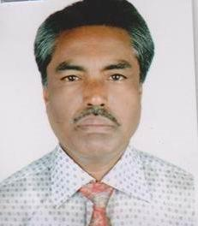 | DR. KAZI ABDUL KHALEQUE  F/Name:  M/Name:  BM & DC Reg. No:  NID:  Cell:  Address: Res. Medical Officer Sadar Hospital Brahmanbaria  Blood Group:
21 | Voter No  LM-0700021  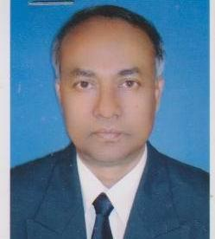 | DR. AHMED AL MAMUN  F/Name:  M/Name:  BM & DC Reg. No:  NID:  Cell:  Address: Bangladesh Gas Fields Co. Ltd. Court Road Brahmanbaria  Blood Group:
22 | Voter No  LM-0700022  No Image | DR. MAJOR RTD. HAROON AL-RASHID  F/Name:  M/Name:  BM & DC Reg. No:  NID:  Cell:  Address: Lakshmi Clinic Kuti Bazar, Kasba Brahmanbaria  Blood Group:
23 | Voter No  LM-0700023  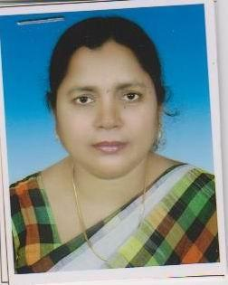 | DR. RAHIMA KHATUN  F/Name:  M/Name:  BM & DC Reg. No:  NID:  Cell:  Address: Kalai Sree Para Brahmanbaria  Blood Group:
24 | Voter No  LM-0700024  No Image | DR. MD. IQBAL HOSSAIN  F/Name:  M/Name:  BM & DC Reg. No:  NID:  Cell:  Address: Medical Officer H.F.P Nabinagar THC Brahmanbaria  Blood Group:
25 | Voter No  LM-0700025  No Image | DR. K.M. AZAD  F/Name:  M/Name:  BM & DC Reg. No:  NID:  Cell:  Address: Medical Officer Nabinagar THC Brahmanbaria  Blood Group:
26 | Voter No  LM-0700026  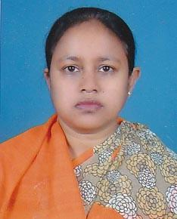 | DR. SHAHINAJ JAHAN  F/Name:  M/Name:  BM & DC Reg. No:  NID:  Cell:  Address: Jr. Consultant Sadar Hospital Brahmanbaria  Blood Group:
27 | Voter No  LM-0700027 | DR. MD. ABU SAYED  F/Name:  M/Name:  BM & DC Reg. No:  NID:  Cell:  Address: Border Bazar Brahmanbaria  Blood Group:
28 | Voter No  LM-0700028  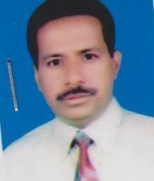 | DR. MD. OBAIDUR RAHMAN  F/Name:  M/Name:  BM & DC Reg. No:  NID:  Cell:  Address: Medical Officer Sadar Hospital Brahmanbaria  Blood Group:
29 | Voter No  LM-0700029  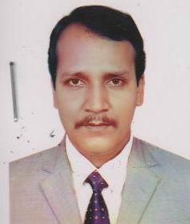 | DR. A.K.M. HARUNUR RASHID  F/Name:  M/Name:  BM & DC Reg. No:  NID:  Cell:  Address: Nurmahal Maddhapara Brahmanbaria  Blood Group:
30 | Voter No  LM-0700030  No Image | DR. MD. ILIAS MIA  F/Name:  M/Name:  BM & DC Reg. No:  NID:  Cell:  Address: Lechaliapara Sarail, Brahmanbaria  Blood Group:
31 | Voter No  LM-0700031  No Image | DR. MOINUDDIN AHMED CHOWDHURY  F/Name:  M/Name:  BM & DC Reg. No:  NID:  Cell:  Address: Titas General Hospital Paikpara Brahmanbaria  Blood Group:
32 | Voter No  LM-0700032  No Image | DR. NARAYAN CHANDRA SAHA  F/Name: Late Harendra Chandra Saha  M/Name:  BM & DC Reg. No: 15356  NID:  Cell:  Address: Senior Consultant Sadar Hospital, Brahmanbaria  Blood Group:
33 | Voter No  LM-0700033  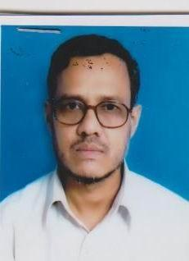 | DR. MD. YEAMLI KHAN  F/Name:  M/Name:  BM & DC Reg. No:  NID:  Cell:  Address: Medical Officer Sadar Hospital Brahmanbaria  Blood Group:
34 | Voter No  LM-0700034  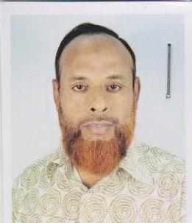 | DR. MD. SHOHRAB MIA  F/Name: Late Arab Ali  M/Name:  BM & DC Reg. No:  NID:  Cell:  Address: Ashugonj Brahmanbaria  Blood Group:
35 | Voter No  LM-0700035  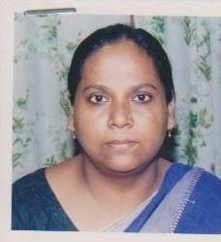 | DR. SHAHAN ARA BEGUM  F/Name: Md. Abdul Karim  M/Name:  BM & DC Reg. No:  NID:  Cell:  Address: Station Road, Char Chartola Ashugonj, Brahmanbaria  Blood Group:
36 | Voter No  LM-0700036  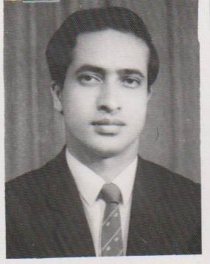 | DR. MD. ABDULLAH AL MAHMUD  F/Name: Late Md. Abdun Noor  M/Name:  BM & DC Reg. No:  NID:  Cell:  Address: Station Road Ashugonj Brahmanbaria  Blood Group:
37 | Voter No  LM-0700037  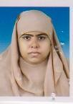 | DR. ISMAT ARA BEGUM  F/Name: Md. Monowar Ali  M/Name: Umeda Khatun  BM & DC Reg. No: 26541  NID: 1219476338761  Cell: 01190341931  Address: Totini - 1, Bangladesh Gas Fields Head Office Complex, Birashar,Brahmanbaria.  Blood Group: O+
38 | Voter No  LM-0700038 | DR. BISHNU PADA BHOWMIK  F/Name: Gopal Chandra Bhowmik  M/Name: Rasamoti Bhowmik  BM & DC Reg. No: 41207  NID: 1221308339638  Cell: 01716087911  Address: H/N - 222, Vill: Kazi Para PO, Thana & Dist: Brahmanbaria.  Blood Group: O+
39 | Voter No  LM-0700039 | DR. AVIJIT ROY  F/Name: Amorandra Lal Roy  M/Name: Bina Rani Roy  BM & DC Reg. No: 46629  NID:  Cell: 01711376646  Address: Bina Bhobon, Porbo paike para, Brahmanbaria.  Blood Group: O+
40 | Voter No  LM-0700040 | DR. A.R.M. IBRAHIM  F/Name: Late Alahaj Md Idris  M/Name: Mrs. Rezia Khatoon  BM & DC Reg. No: 12160  NID: 1221303304412  Cell: 01711407765  Address: 548, Fulbaria, Brahmanbaria.  Blood Group: O+
41 | Voter No  LM-0700041  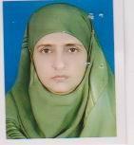 | DR. HASINA AKHTER BEGUM  F/Name: Late Nurul Islam Bhuiyan  M/Name: Mrs. Majeda Akhter  BM & DC Reg. No: 13382  NID:  Cell: 017113474413  Address: 1003, College Para, Brahmanbaria  Blood Group: B+
42 | Voter No  LM-0700042  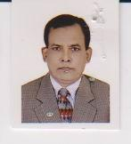 | DR. ABU SALEH MD. MUSA KHAN  F/Name: Late Md. Abdul Jabbar Khan  M/Name:  BM & DC Reg. No:  NID:  Cell:  Address: Jute Godown Road East Paikpara Brahmanbaria  Blood Group:
43 | Voter No  LM-0700043 | DR. MD. SHOWKAT HOSSAIN  F/Name: Late Abul Quasem Bhuiyan  M/Name:  BM & DC Reg. No:  NID:  Cell:  Address: Upazila Health Complex Sadar, Brahmanbaria.  Blood Group:
44 | Voter No  LM-0700044 | DR. MD. MOKBUL HOSSAIN  F/Name: Late Nurul Islam  M/Name:  BM & DC Reg. No:  NID:  Cell:  Address: AD (CC) District Family Planning Office Brahmanbaria  Blood Group:
45 | Voter No  LM-0700045 | DR. PRIYABRATA ROY SUPRIYA  F/Name: Late Pratap Ranjan Roy  M/Name:  BM & DC Reg. No:  NID:  Cell:  Address: Modern X-Ray Clinic Hospital Road Brahmanbaria.  Blood Group:
46 | Voter No  LM-0700046  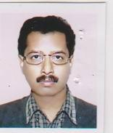 | DR. RANA NURUS SHAMS  F/Name: Md. Mohsin  M/Name:  BM & DC Reg. No:  NID:  Cell:  Address: Medical Officer, Chest Disease Hospital Medda, Brahmanbaria.  Blood Group:
47 | Voter No  LM-0700047 | DR. GAZI MD. ABDUL MANNAN  F/Name: Late Gazi Md. Elahi Boska  M/Name:  BM & DC Reg. No:  NID:  Cell:  Address: Kandipara, Brahmanbaria.  Blood Group:
48 | Voter No  LM-0700048 | DR. ARUNABHA PODDAR  F/Name: Amiya Bhushan Poddar  M/Name:  BM & DC Reg. No:  NID:  Cell:  Address: Titas Gen. Hospital & Health Care Moulovi Para, Brahmanbaria.  Blood Group:
49 | Voter No  LM-0700049 | DR. MD. FAKHRUL ALAM  F/Name: Late Md. Abdur Rashid  M/Name: Late Mst. Sufia Khatoon  BM & DC Reg. No: 26212  NID: 1221302301278  Cell: 01711377901  Address: Alam Manjeel, West Paik Para, Jail Road, Brahmanbaria.  Blood Group: O+
50 | Voter No  LM-0700050  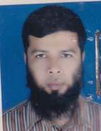 | DR. MD. ZAKARIA  F/Name: Md. Abdul Haque  M/Name: Mrs. Josna Begum  BM & DC Reg. No: 24910  NID: 1221302302069  Cell: 01712006090  Address: Shimrailkandi, Brahmanbaria.  Blood Group: A+
51 | Voter No  LM-0700051 | DR. TOFAIL HOQUE  F/Name: Late Azizul Hoque  M/Name: Rahela Begum  BM & DC Reg. No: 26254  NID: 1221301295499  Cell: 01711357771  Address: Madda Sabuj Bagh Brahmanbaria..  Blood Group: O+
52 | Voter No  LM-0700052  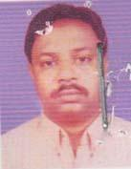 | DR. MD. SHAFIUL ALAM  F/Name: Md. Nazrul Islam  M/Name: Noorjahan Begum  BM & DC Reg. No: 26474  NID: 1221308346168  Cell: 01819934415  Address: Noorjahan vila, West KaziPara, P.O Brahmanbaria.  Blood Group: B+
53 | Voter No  LM-0700053 | DR.MOHAMMAD ZAHIRUL ISLAM  F/Name: Md. Abu Bakar  M/Name: Ofia Begum  BM & DC Reg. No: 31489  NID: 1221305323613  Cell: 01716918918  Address: Doctors Quarter, Sadar Hospital, B.Baria.  Blood Group: B+
54 | Voter No  LM-0700054  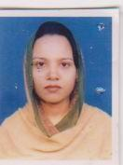 | DR. SHAILA SULTANA JHUMA  F/Name: Md. Abdul Hakim  M/Name: Momtaz Begum  BM & DC Reg. No: 40530  NID: 1221305323611  Cell:  Address: Doctors Quarter, Sadar Hospital, B.Baria.  Blood Group:
55 | Voter No  LM-0700055 | DR. MIJANUR RAHMAN  F/Name: Shafiqur Rahman  M/Name: Saleha Begum  BM & DC Reg. No: 27762  NID: 1221309346484  Cell: 01716518915  Address: Vill: South Mourail, Post&Dist: B.Baria.  Blood Group: O+
56 | Voter No  LM-0700056  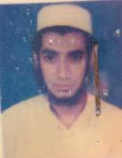 | DR. A.K.M. SHAHEDUZZAMAN  F/Name: Md. Sultan Ali  M/Name: Mst Shamsun Nahar  BM & DC Reg. No: 27464  NID: 1221302300772  Cell: 01199331113  Address: Junior Consultant Medicine Sadar Hospital, B.Baria.  Blood Group: O+
57 | Voter No  LM-0700057 | DR. DUKE CHOWDHURY  F/Name: Late Dr. Salil Kumar Chowdhury  M/Name: Mrs. Tripti Chowdhury  BM & DC Reg. No: 28962  NID: 1221310358834  Cell: 0171593330  Address: Christian Medical Centre, Mourail PO & Dist: B.Baria.  Blood Group: O+
58 | Voter No  LM-0700058 | DR. ANGELA CHOWDHURY  F/Name: Dr. S.m. Chowdhury  M/Name:  BM & DC Reg. No:  NID:  Cell:  Address: Christian Mecical Centre, Mourail Brahmanbaria.  Blood Group:
59 | Voter No  LM-0700059 | DR. MOHAMMAD MONIR HOSSAIN  F/Name: Mohammad Abdur Rashid  M/Name: Shamsun Nahar  BM & DC Reg. No: 29872  NID: 1221302301370  Cell: 01711261736  Address: Sadar Hospital, B.Baria.  Blood Group: B+
60 | Voter No  LM-0700060  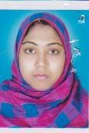 | DR. AYESHA SIDDIKA  F/Name: Md. Hanif  M/Name:  BM & DC Reg. No:  NID:  Cell:  Address: Sadar Hospital Brahmanbaria.  Blood Group:
61 | Voter No  LM-0700061 | DR. MD. RUHUL AMIN  F/Name: Abdul Karim  M/Name:  BM & DC Reg. No:  NID:  Cell:  Address: 858, Moulavi Para Brahmanbaria.  Blood Group:
62 | Voter No  LM-0700062  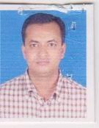 | DR. MUHAMMAD AL-AMIN  F/Name: Muhammad Zillur Rahman  M/Name:  BM & DC Reg. No:  NID:  Cell:  Address: Medical Officer, Sadar Hospital Brahmanbaria.  Blood Group:
63 | Voter No  LM-0700063 | DR. A.K.M. HABIBULLAH BAHAR  F/Name: Mohammad Abdul Mannan  M/Name: Habiba Aktar  BM & DC Reg. No: 33869  NID:  Cell: 01673140576  Address: Asroy H/No: 220-1; Munsef Para B.Baria.  Blood Group: O+
64 | Voter No  LM-0700064 | DR. SURAYA AKTER  F/Name: Md. Taleb Hosain  M/Name: Amena Begum  BM & DC Reg. No: 33870  NID:  Cell: 01711315842  Address: Asroy House No: 220-1 Munsef Para,B.Baria.  Blood Group: A+
65 | Voter No  LM-0700065 | DR. MD JOBAYER SHAFIN  F/Name: Grindra Kumar Sarkar  M/Name: Kollani Sarkar  BM & DC Reg. No: 37101  NID: 1221303308827  Cell: 01735497957  Address: Prantobas, Baganbari, B.Baria.  Blood Group: O+
66 | Voter No  LM-0700066 | DR. SARBIN BOBY SULTANA  F/Name: Md. Shahajahan Meah  M/Name: Sultana Begum  BM & DC Reg. No: 42313  NID: 1221303309288  Cell: 01728630014  Address: Prantobas, BaganBari, B.Baria.  Blood Group: A+
67 | Voter No  LM-0700067 | DR. MD. SHAH ALAM  F/Name: Late Abdus Sobhan  M/Name: Mrs. Halima Begum  BM & DC Reg. No: 21048  NID: 1218547975171  Cell: 01711162488  Address: UHC Akhaura, B.Baria.  Blood Group: A+
68 | Voter No  LM-0700068 | DR. KHOKON CHANDRA DEBNATH  F/Name: Shetal Chandra Debnath  M/Name: Rani Debnath  BM & DC Reg. No: 52422  NID: 9196202119907  Cell: 01713661908  Address: 91/1, East Paikpara, Brahmanbaria  Blood Group: O+
69 | Voter No  LM-0700069 | DR. SHYAMAL RANJAN DEBNATH  F/Name: Haripad Debnath  M/Name: Ava Rani Debnath  BM & DC Reg. No: 43180  NID: 2695431007983  Cell: 01710818668  Address: Vill: Akanagar, P.O:&P.S: Salimgong, Bancharampur, Dist: B.Baria.  Blood Group: O+
70 | Voter No  LM-0700070 | DR. MD. NAZRUL HOSSAIN MULLAH  F/Name: Md. Abul Hossain Mullah  M/Name: Shamsia Akter Khanam  BM & DC Reg. No: 48921  NID:  Cell: 01818176880  Address: 1160, West Paikpara, B.Baria.  Blood Group: A+
71 | Voter No  LM-0700071 | DR. RUPAJYOTI DEV  F/Name: Late Durgesh Chandra Dev  M/Name: Gita Rani Dev  BM & DC Reg. No: 37626  NID:  Cell: 01712180833  Address: Christian Medical Centre, Brahmanbaria-3400.  Blood Group:
72 | Voter No  LM-0700072 | DR. MD. SARWAR ALAM  F/Name: Late Md. Abdul Gafur  M/Name: Late Mrs. Amirun Nesa  BM & DC Reg. No: 10985  NID: 1219087785566  Cell:  Address: Uhrfpo Nasir Nagar Upzilla Health Complex B.Baria.  Blood Group: B+
73 | Voter No  LM-0700073 | DR. MD. OBIDUL HOQUE  F/Name: Md. Abdul Alim  M/Name: Morium Begum  BM & DC Reg. No: 49984  NID:  Cell: 01716735224  Address: 914, Halder Para (2nd Floor) B.Baria.  Blood Group:
74 | Voter No  LM-0700074 | DR. O.Z.M DASTAGIR  F/Name: A.s.m. Shahidul Hoque  M/Name: Begum Rahima Haque  BM & DC Reg. No: 46867  NID: 1218581814993  Cell: 01712202834  Address: C/O Dr. Abu Sayed, Maddhya Para, Border Bazar, B.Baria.  Blood Group: B+
75 | Voter No  LM-0700075 | DR. FORHAD HOSSAIN MD. SHAHED  F/Name: Ahmed Hosain  M/Name: Rokeya Begum  BM & DC Reg. No: 26972  NID:  Cell: 01711271071  Address: Central Lab Diagonostic Centre, Kumershilmore, B,Baria.  Blood Group:
76 | Voter No  LM-0700076 | DR. CHINMOY KUMAR SAHA  F/Name: Late Pabitra Bisaree Saha  M/Name: Jotsna Saha  BM & DC Reg. No: 30525  NID:  Cell: 01715282624  Address: Sadar Hospital, B.Baria.  Blood Group: B+
77 | Voter No  LM-0700077 | DR. MD. ABUL KALAM AZAD  F/Name: Md. Abdul Awal  M/Name: Begum Jahanara  BM & DC Reg. No: 24832  NID: 2610457048601  Cell: 01711230171  Address: Ward - 04, MAG Osmani Medical College Hospital, Sylhet.  Blood Group: O+
78 | Voter No  LM-0700078 | DR. GOLAM MORTAZA KHANDAKAR  F/Name: Late Mawlana Hakim Golam Mostafa  M/Name: Late Kazi Asia Khanam  BM & DC Reg. No: 6841  NID:  Cell: 01558371093  Address: Central Lab  Blood Group:
79 | Voter No  LM-0700079 | DR. SUMANTA KUMER SAHA  F/Name: Sritosh Chandra Saha  M/Name: Gorika Rani Saha  BM & DC Reg. No: 42707  NID:  Cell: 01729097404  Address: 407, Moddhapara, 4th Floor, Brahmanbaria 3400  Blood Group:
80 | Voter No  LM-0700080 | DR. S.M. ZAKIR HOSSAIN  F/Name:  M/Name:  BM & DC Reg. No: 34692  NID: 2697557398096  Cell: 01716929544  Address: Senior Consaltant Paedialrics, B.Baria Medical College Hospital, Ghatura, B.Baria.  Blood Group: B+  TRANSFERED to BMA Dhaka City  LM-1405543
81 | Voter No  LM-0700081 | DR. MD. MAKBUL HOSSAIN  F/Name: Md. Ahmed Hossain  M/Name: Begum Rezia Mahmud  BM & DC Reg. No: 56963  NID: 19861594116394543  Cell: 01718059792  Address: RMO, B.Baria Medical College Hospital, Ghatura, B.Baria.  Blood Group: O+
82 | Voter No  LM-0700082  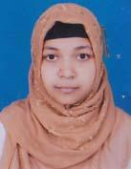 | DR. NUSRAT JAHAN  F/Name: Mohammad Ali  M/Name: Hasmet Ara Begum  BM & DC Reg. No: 4078  NID:  Cell: 01754694194  Address: Dental Surgeor, B.Baria Medical College Hospital, Ghatura, B.Baria.  Blood Group: A+
83 | Voter No  LM-0700083 | DR. MD. EMRANUL HAQUE  F/Name: Md. Muzammerl Haque  M/Name: Mrs, Khorsheda Begum  BM & DC Reg. No: 11612  NID: 1221304317622  Cell: 01715594488  Address: Mukti Hospital Masjid Road, B.Baria.  Blood Group: O+
84 | Voter No  LM-0700084  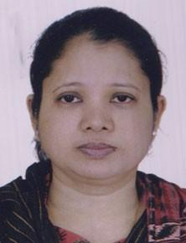 | DR. FERDOUSA BEGUM  F/Name: Md. Abdul Wahed  M/Name: Ambia Wahed  BM & DC Reg. No: 26258  NID:  Cell: 01711907157  Address: Meehti, Hospital, Brahmanbaria.  Blood Group:
85 | Voter No  LM-0700085 | DR. MD. SADEQUE MIAH  F/Name: Md. Waresh Ali  M/Name: Mrs. Asia Khatun  BM & DC Reg. No: 15672  NID: 1218547970752  Cell: 01719675356  Address: Doctors Quarter, Upazila Health Complex, Nabinagar, P.O: Nabinagar, Dist: B.Baria.  Blood Group: B+
86 | Voter No  LM-0700086 | DR. MOH. ABDUS SALAM SIKDER  F/Name: Md. Abdur Razzak  M/Name: Late Jamila Khatun  BM & DC Reg. No: 47762  NID: 1210477268095  Cell: 01711949931  Address: Upazila Health Complex, Bancharampur, B.Baria.  Blood Group: O+
87 | Voter No  LM-0700087 | DR. GOPA PAUL  F/Name: Gobinda Chandra Paul  M/Name: Sabitri Rani Paul  BM & DC Reg. No: 49366  NID: 1221305799158  Cell: 01912244276  Address: Vill: Maddha Para, P.O: B.Baria, Dist: B.Baria.  Blood Group: O+
88 | Voter No  LM-0700088  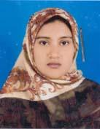 | DR. MASRURA SIDDIQUE (MOMY)  F/Name: A.k. Mohammad Ali  M/Name: Mahfuza Khanum  BM & DC Reg. No: 48922  NID:  Cell: 01816905602  Address: 1160, West Paik Para, Brahmanbaria.  Blood Group:
89 | Voter No  LM-0700089  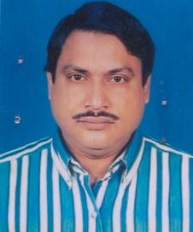 | DR. MD GOLAM MOSTAFA  F/Name: Anwar Hossain Akond  M/Name: Late Mst: Khadiza Begum  BM & DC Reg. No: 14059  NID: 4624904181321  Cell: 01715004592  Address: Junior Consultant Aortho- Surgery, Sadar Hospital, B.Baria.  Blood Group: O+
90 | Voter No  LM-0700090 | DR.MD. MAHMUDUL HASAN  F/Name: A.k.m. Amjed Ali  M/Name: Noor Jahan Begum  BM & DC Reg. No: 45582  NID:  Cell: 01911976262  Address: H/N- 1028, College Para, B.Baria.  Blood Group:
91 | Voter No  LM-0700091 | DR. MD. FAIZUR RAHMAN  F/Name: Md. Ataur Rahman  M/Name: Mrs. Majeda Begum  BM & DC Reg. No: 48543  NID: 1022014236732  Cell: 01711321319  Address: House No: 858, (4th Floor), Samorita Hospital Moulovi para, B.Baria.  Blood Group: A+
92 | Voter No  LM-0700092 | DR. MD. ABDUR ROB  F/Name: Late Zainul Abedin  M/Name: Mrs. Zakia Begum  BM & DC Reg. No: 30462  NID: 2691648034312  Cell: 01714080593  Address: Junior Consultant, CDC, B.Baria.  Blood Group: B+
93 | Voter No  LM-0700093 | DR. FAISAL AL AHASAN  F/Name: Md. Ahsan Ullah  M/Name: Sk. Nilufar Akhter  BM & DC Reg. No: 47109  NID:  Cell: 01746688002  Address: Khasru Sriti Sadar, Katakhali, Ashugonj, B.Baria.  Blood Group: B+
94 | Voter No  LM-0700094 | DR. KHONDAKER MOBASHER AHMED  F/Name: Md. Muslim Khondaker  M/Name: Nurunnahar Begum  BM & DC Reg. No: 45339  NID: 9196203131303  Cell:  Address: 555, Baitul Monowar, Kandipara, B.Baria.  Blood Group: B+
95 | Voter No  LM-0700095 | DR. MD. ABU BAKAR SIDDIQUE  F/Name: Shahjahan Majumdar  M/Name: Mst: Ummay Kulsum  BM & DC Reg. No: 51273  NID: 6125217227680  Cell:  Address: Ashuganj, East Market, Asuganj, B.Baria.  Blood Group: A+
96 | Voter No  LM-0700096  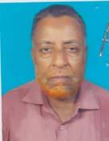 | DR. ABDUL MOMIN  F/Name: Abdul Aziz  M/Name: Karimunnesa  BM & DC Reg. No: 10173  NID: 1220207714235  Cell: 01716869655  Address: Akhaura, B.Baria.  Blood Group: A+
97 | Voter No  LM-0700097 | DR. MD. AHSANUL HAQUE KAWSAR  F/Name: Late Md. Muksudul Haque  M/Name: Mrs. Arjuda Khanam  BM & DC Reg. No: 31255  NID: 1221310360087  Cell: 01711738721  Address: 836, College Para, B.Baria.  Blood Group: A+
98 | Voter No  LM-0700098 | DR. MD. NUR ALAM MOHIM  F/Name:  M/Name:  BM & DC Reg. No: 51317  NID:  Cell: 01717218357  Address: Sadar Hospital Quarter, B.Baria.  Blood Group: A+  TRANSFERED to BMA Dhaka City  LM-1405543
99 | Voter No  LM-0700099 | DR. MD. NOMAN MIAH  F/Name: Late Abdul Malek  M/Name: Late Rokeya Begum  BM & DC Reg. No: 30780  NID:  Cell:  Address: Digant RMO Quarter, Upazila Health Complex, Brahmonbaria.  Blood Group: A+
100 | Voter No  LM-0700100 | DR. MAHFIDA AKTER  F/Name: Md Abdul Hai  M/Name: Hasna Begum  BM & DC Reg. No: 51087  NID:  Cell: 01731032414  Address: Mizan Tower, B.Baria.  Blood Group:
101 | Voter No  LM-0700101 | DR. A.B.M. MUSA CHOWDHURI  F/Name: Farid Uddin Ahmed  M/Name: Rashida Begum  BM & DC Reg. No: 46704  NID:  Cell: 01711130272  Address: B.Baria Auto Rice Mill, Hajee Sobhan Sowdagar Road.  Blood Group: A+
102 | Voter No  LM-0700102 | DR. TANZIA FERDOUS  F/Name: A.s.m. Ubaidul Huq  M/Name: Late. Nasima Begum  BM & DC Reg. No: 39260  NID:  Cell: 01917531641  Address: Raj Bhabon, PaikPara, B.Baria.  Blood Group: O+
103 | Voter No  LM-0700103  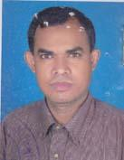 | DR. MD. AKTER HOSSAIN  F/Name: Late Md. Wahid Miah  M/Name: Mrs. Anwara Begum  BM & DC Reg. No: 36773  NID: 1221305323579  Cell: 01711270593  Address: Assist Registered Sadar Hospital, B.Baria.  Blood Group: A+
104 | Voter No  LM-0700104 | DR. SHARMIN SULTANA  F/Name: Hamidur Rahman  M/Name: Mahmuda Begum  BM & DC Reg. No: 53233  NID: 1221303307284  Cell:  Address: Maddhapara 364 Jalilur Road, B.Baria.  Blood Group: B+
105 | Voter No  LM-0700105  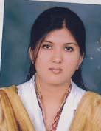 | DR.MIR NYMA JAHAN  F/Name: Mir. Anwar Hossain  M/Name: Mir. Salma Akter  BM & DC Reg. No: 53988  NID: 2690601922516  Cell: 01745781836  Address: Hazi Alfat Ali Builsing, Ashugonj Bazar, P.O: Ashugonj, Dist: B.Baria.  Blood Group: A+
106 | Voter No  LM-0700106 | DR. JAKIA SULTANA RUNA  F/Name: Md. Abdur Rahim  M/Name: Mrs. Firoza Akter  BM & DC Reg. No: 41260  NID: 2697407840848  Cell: 01716376716  Address: Sadar Hospital Quarter, Sadar, B.Baria  Blood Group:
107 | Voter No  LM-0700107 | DR. ABU ZAFAR MOHAMMAD SAIF UDDIN  F/Name: Abdul Matin  M/Name: Fatema Akter  BM & DC Reg. No: 32748  NID: 1918110514664  Cell: 01711112456  Address: Medical Officer, Sadar Hospital, B.Baria.  Blood Group:
108 | Voter No  LM-0700108 | DR. ABUL BASHAR MD. SAJJAD  F/Name: Late Alhaj Abdus Samad  M/Name: Late Mrs. Samsun Nahar Begum  BM & DC Reg. No: 17952  NID: 1221305323640  Cell: 01711021990  Address: 645, South Mourail , Duk Banglow Road, B.Baria.  Blood Group:
109 | Voter No  LM-0700109 | DR. SAIKAT NANDY  F/Name: Dayal Nandy  M/Name: Shuvra Nandy  BM & DC Reg. No: 40122  NID:  Cell: 01917009535  Address: Kazipara diabetic Centre, B.Baria.  Blood Group: O+
110 | Voter No  LM-0700110 | DR. MOHAMMAD MOSTAFA KAMAL  F/Name: Dr. Md. Sohrab Mia  M/Name: Sayda Parvin  BM & DC Reg. No: 47908  NID: 1213314100413  Cell: 01824540934  Address: Titash Medical Hall, Ashugoni Bazar, Ashugonj, B.Baria.  Blood Group: O+
111 | Voter No  LM-0700111 | DR. BISHWA NATH BHOWMIK  F/Name: Gopal Chandra Bhowmik  M/Name: Rashmati Bhowmik  BM & DC Reg. No: 44738  NID:  Cell:  Address: 451, Prof Haralal Roy Road, East Paik Para, B.Baria.  Blood Group: O+
112 | Voter No  LM-0700112 | DR. MD. EUNUS ALI  F/Name: Late Hazi Lutfor Rahman  M/Name: Mrs. Haji Halema Khatun  BM & DC Reg. No: 22063  NID:  Cell: 01711103019  Address: R.M.O. UHC, Nabinagar, B.Baria.  Blood Group:
113 | Voter No  LM-0700113  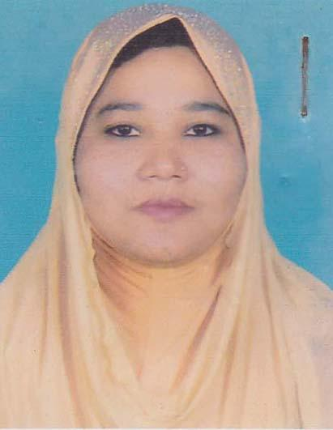 | DR. FOUZIA AKHTER  F/Name: Md. Abdur Rashid  M/Name: Mrs. Morium Begum  BM & DC Reg. No: 30662  NID:  Cell: 01720990343  Address: Modok Bari Lane, B.Baria  Blood Group: B+
114 | Voter No  LM-0700114 | DR. ASIF IQBAL  F/Name: Ahmed Salek  M/Name: Sufia Ahmed  BM & DC Reg. No: 20970  NID: 1211350483727  Cell: 01715317856  Address: 4, Lipika, Location (B), Titas-Road, Ghatura, B.Baria.  Blood Group: O+
115 | Voter No  LM-0700115 | DR. WAKILA TABASSUM BARNA  F/Name: Late Mafizul Islam  M/Name: Late Shahana Islam  BM & DC Reg. No: 55912  NID:  Cell: 01721322642  Address: Alam, Manjeel, West Paikpara, Jail Road, B.Baria.  Blood Group:
116 | Voter No  LM-0700116 | DR. FOZIA ZAFRIN  F/Name: K.m Zahirul Haque  M/Name: Hena Begum  BM & DC Reg. No: 49044  NID: 1221309346350  Cell: 01717099573  Address: South Mourail Behind Islamic Forndation, B.Baria.  Blood Group: A+
117 | Voter No  LM-0700117 | DR.TOWHID AHAMED CHOWDHURY  F/Name: Abu Kowser Chowdhury  M/Name: Rahima Begum  BM & DC Reg. No: 48054  NID:  Cell: 01913843336  Address: B.baria General Hospital  Blood Group:
118 | Voter No  LM-0700118 | DR. MD AZHARUR RAHMAN  F/Name: Dr. Abdul Kadir  M/Name: Mrs. Khursheda Zahan  BM & DC Reg. No: 28090  NID:  Cell: 01817296190  Address: Niramay Clinic, Halder para,B.Baria.  Blood Group: O+
119 | Voter No  LM-0700119  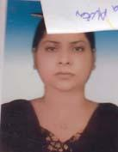 | DR. NASIMA AKHTER  F/Name: Md. Bashir Uddin Ahmed  M/Name: Mrs. Rafiqun Nahar Chowdhury  BM & DC Reg. No: 28091  NID:  Cell: 01818340883  Address: Niramoy Clinic Halder Para, B.Baria.  Blood Group: A+
120 | Voter No  LM-0700120  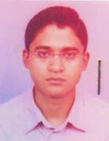 | DR.MUJTAHID MOHAMMAD HOSSAIN  F/Name: Iqbal Hossain  M/Name: Shamsunnahr Hossain  BM & DC Reg. No: 30425  NID: 1221303304217  Cell: 01715597826  Address: House No: 537, Ward No: 3 Fulbari, P.O: B.Baria, Dist:B.Baria.  Blood Group: B+
121 | Voter No  LM-0700121 | DR. MOHAMMAD NEJAM UDDIN  F/Name: Mohammad Abdhul Mozid  M/Name: Zahera Khatun  BM & DC Reg. No: 40276  NID: 21546523425  Cell: 01913129628  Address: 848/1, Mowlovipara, Haldar Para Road, Brahmanbaria  Blood Group: B+
122 | Voter No  LM-0700122  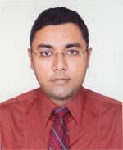 | MD. MOSTAFIZUR RAHMAN KHAN  F/Name: Late Md. Mukhlesur Rahman Khan  M/Name: Late Monowara Rahman  BM & DC Reg. No: 2568  NID: 124578523215  Cell: 01711489093  Address: 847, Khan Monjil, College Para, Brahmanbaria  Blood Group: O+
123 | Voter No  LM-0700123 | DR. FARHANA YESMIN  F/Name: Abdul Jabbar  M/Name: Rozina Jabbar  BM & DC Reg. No: 67867  NID: 1221306329529  Cell: 01812914122  Address: House No. 661/75, Gocorn Road, South Poirtola, Brahmanbaria  Blood Group: O+
124 | Voter No  LM-0700124 | DR. A K M NIZAM UDDIN  F/Name: Mohammed Nasir Uddin  M/Name: Mrs. Sayesta Begum  BM & DC Reg. No: 39468  NID: 1221310358752  Cell: 01730179743  Address: House No. 546, South Mourail, Brahmanbaria  Blood Group: AB+
125 | Voter No  LM-0700125 | DR. KHADIJA BEGUM  F/Name: Abdul Hakim Bhuiyan  M/Name: Mrs. Halima Begum  BM & DC Reg. No: 54338  NID: 12224542152  Cell: 01913129627  Address: 848/1, Mowlovipara, Haldarpara Road, Brahmanbaria  Blood Group: B+
126 | Voter No  LM-0700126 | DR. ABU REZA SAYEM AHAMED  F/Name: Abdur Razzaque  M/Name: Lutfa Shirien Noor  BM & DC Reg. No: 31862  NID: 2696654324810  Cell: 0171442674  Address: Consultant Quarter, Sadar Hospital, Brahmanbaria  Blood Group: O+
127 | Voter No  LM-0700127 | DR. MAQSUDA BEGUM  F/Name: Md. Moazzem Hossain  M/Name: Hosne Ara Hossain  BM & DC Reg. No: 31861  NID: 2696654324775  Cell: 01719894825  Address: Consultant Quarter, Sadar Hospital, Brahmanbaria  Blood Group: B+
128 | Voter No  LM-0700128 | DR. MD. MEHEDI HASAN  F/Name: Md. Nurul Islam  M/Name: Selina Begum  BM & DC Reg. No: 69989  NID: 19902696828000329  Cell: 01920167369  Address: Grameen Hospital, Barhmanbaria  Blood Group: O+
129 | Voter No  LM-0700129 | DR. MD. REZUAN ULLAH  F/Name: Md. Abdus Sattar  M/Name: Rokeya Begum  BM & DC Reg. No: 68885  NID: 19901219494000008  Cell: 01521434423  Address: House No. 337, Moddhapara, Brahmanbaria Sadar, B. Baria  Blood Group: B-
130 | Voter No  LM-0700130 | DR. KAZI ASHRAFUR RAHMAN  F/Name: Kazi Ahmadur Rahman  M/Name: Mrs. Mokarroma Begum  BM & DC Reg. No: 66492  NID: 9196201102629  Cell: 01749299257  Address: Fatema Sawkat Villa, 379, Kazi Para, Dopabari, Brahmanbaria  Blood Group: B+
131 | Voter No  LM-0700131 | DR. KAMRUN NAHAR BEGUM  F/Name: Abdul Gafur Bhuiyan  M/Name: Fatema Khatun  BM & DC Reg. No: 41781  NID: 9196203124871  Cell: 01711065087  Address: 96, West Paikpara, Brahmanbaria  Blood Group: O+
132 | Voter No  LM-0700132  No Image | ***NIL***  F/Name:  M/Name:  BM & DC Reg. No:  NID:  Cell:  Address:  Blood Group:
133 | Voter No  LM-0700133 | DR. MOHAMMAD ABUL EHSAN  F/Name: Abul Bashar Mohammad Mohiuddin  M/Name: Gulshan Ara Begum  BM & DC Reg. No: 30146  NID: 2692986570974  Cell: 01914473672  Address: Sadar Hospital, Brahmanbaria  Blood Group: O+
134 | Voter No  LM-0700134  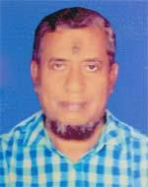 | DR. MD. ZAHIRUL HAQ  F/Name: Late Alhaj Abdul Hafiz  M/Name: Late Ayesha Khaton  BM & DC Reg. No: 11048  NID: 4821101654627  Cell: 01912456903  Address: Medical officer, B. Baria Diabetis Sonitee, B. Baria  Blood Group: B+
135 | Voter No  LM-0700135 | DR. MAHJABIN MUNMUN  F/Name: Ad. Minto Bhowmick  M/Name: Ad. Mira Bhowmick  BM & DC Reg. No: 73918  NID:  Cell: 01196123025  Address: C/O Abdul Motin House No. 421, Gokorra Road, Kazi Para, Brahmanbaria  Blood Group: A+
136 | Voter No  LM-0700136  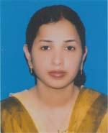 | DR. SUCHITTRA RANI DUTTA  F/Name: Late Santi Ram Dutta  M/Name: Suniti Dutta  BM & DC Reg. No: 50845  NID: 8198510364017  Cell: 01718002232  Address: 324, East Paik Para, Brahmanbaria  Blood Group: O+
137 | Voter No  LM-0700137 | DR. CHAYAN ROY  F/Name: Mohini Mohan Roy  M/Name: Suniti Roy  BM & DC Reg. No: 43450  NID: 1221304315225  Cell: 01711364569  Address: 324, East Paik Para, Brahmanbaria  Blood Group: A+
138 | Voter No  LM-0700138 | DR. AMZAD HOSSAIN KHAN  F/Name: Md. Delwar Hossain Khan  M/Name: Mrs. Shefali Akter  BM & DC Reg. No: 62092  NID:  Cell: 01710505634  Address: House No. -256/A, North Morail, B. Baria  Blood Group: B-
139 | Voter No  LM-0700139 | DR. FRANCIS KHAN  F/Name: Late Rev. Subhas Khan  M/Name: Mrs. Amiya Khan  BM & DC Reg. No: 73679  NID: 1221309334713  Cell: 01711047999  Address: 899, South Mourail, Brahmanbaria Sadar, Brahmanbaria  Blood Group: B+
140 | Voter No  LM-0700140 | DR. RAJIB ROY  F/Name: Gurupada Roy  M/Name: Jharna Rani Roy  BM & DC Reg. No: 66080  NID: 1221302301730  Cell: 01732002506  Address: Brahmanbaria Medical College and Hospital  Blood Group: O+
141 | Voter No  LM-0700141 | DR. MOHAMMED SHAYEMUL HUDA  F/Name: Late Samsul Huda  M/Name: Mrs. Shufia Khanom  BM & DC Reg. No: 54939  NID: 19802694813000066  Cell: 01822967860  Address: Doctors Quater, UHC, Nabinagar, Brahmanbaria  Blood Group: O+
142 | Voter No  LM-0700142 | DR. MUSHRAT FARKHANDA JABEEN  F/Name: Mukhlesur Rahman  M/Name: Rafia Rahman  BM & DC Reg. No: 59800  NID: 6125214204896  Cell: 01715788774  Address: Doctors Quarter (Old), 2nd Floor, Nabinagar Upazilla Health Complex, B. Baria  Blood Group: B+
143 | Voter No  LM-0700143 | DR. MD. FOKRUL ISLAM SARKAR  F/Name: Abdul Aziz  M/Name: Aulia Khatun  BM & DC Reg. No: 50309  NID: 19739196201000001  Cell: 01711113295  Address: 833/3, Haldar Para, Sadar, B. Baria  Blood Group: AB+
144 | Voter No  LM-0700144 | DR. MOHAMMAD MOHIUDDIN  F/Name: Md. Serajul Islam  M/Name: Mrs. Razia Sultana  BM & DC Reg. No: 37345  NID: 19751218547000037  Cell: 01710228141  Address: MO, UHC, Nabinagar, Brahmanbaria  Blood Group: B+
145 | Voter No  LM-0700145  No Image | ***NIL***  F/Name:  M/Name:  BM & DC Reg. No:  NID:  Cell:  Address:  Blood Group:
146 | Voter No  LM-0700146 | DR. ILIAS AHAMMAD  F/Name: Md. Humayun Mia  M/Name: Bushira Begum  BM & DC Reg. No: 33832  NID: 1221310365352  Cell: 01787261251  Address: H-497, Kandipara, Brahmanbaria Sadar, Brahmanbaria  Blood Group: O+
147 | Voter No  LM-0700147 | A. F. M MAHABUBUR RAHMAN  F/Name: A. F. M Shafiqur Rahman  M/Name: Sajeda Begum  BM & DC Reg. No: 54488  NID: 2699040690871  Cell: 01678138338  Address: House No. 337, North Mourail, Brahmanbaria  Blood Group: A+
148 | Voter No  LM-0700148 | DR. SAYEEDA SAMIHA  F/Name: Mohammad Abdur Razzaque  M/Name: Mahfuza Akter  BM & DC Reg. No: 54489  NID: 2699040685235  Cell: 01673831352  Address: House No. 337, North Mourail, Brahmanbaria  Blood Group: O+
149 | Voter No  LM-0700149 | DR. MD. RAYHAN UDDIN BHUIYAN  F/Name: Md. Dabir Ahmmed Bhuiyan  M/Name: Rehana Akter  BM & DC Reg. No: 54803  NID: 4798516214813  Cell: 01715480734  Address: Upzilla Health Complex, Kasba, Brahmanbaria.  Blood Group: B+
150 | Voter No  LM-0700150 | DR. MD. ASADUZZAMAN RIFAT  F/Name: Late Helal Uddin Ahmed  M/Name: Chowdhury Meherunnesa  BM & DC Reg. No: 67837  NID:  Cell: 01672028550  Address: West Medda, Brahmanbaria.  Blood Group: O+
151 | Voter No  LM-0700151 | DR. IFTEKHAR AHMED  F/Name: Late Heram Uddin Ahmed  M/Name: Syeda Shaheen Sultana Ahmed  BM & DC Reg. No: 70516  NID: 1221308346257  Cell: 01720986237  Address: Syed Memsian, H. No. 971, West Kazipara, Golormo Road, Brahmanbaria  Blood Group: B+
152 | Voter No  LM-0700152 | DR. MD. KAMRUL HASAN  F/Name: Md. Amzad Ali  M/Name: Nur Jahan Begum  BM & DC Reg. No: 49358  NID: 1221310358891  Cell: 01920632020  Address: House No. 1028, College Para, Brahmanbaria  Blood Group: O+
153 | Voter No  LM-0700153  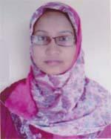 | DR. JANNATUL FERDOUS  F/Name: Ak Lokman Hakim  M/Name: Mst. Halima Khatun  BM & DC Reg. No: 51301  NID: 6125214204936  Cell: 01745500655  Address: B-10/4, Officers Quarter, APSCL Ashuganj, Brahmanbaria  Blood Group: B+
154 | Voter No  LM-0700154 | DR. MD. SHAHIDUL HASSAN  F/Name: Md. Afzal Hossain  M/Name: Jotsna Begum  BM & DC Reg. No: 53441  NID: 19858199017314600  Cell: 0199121335  Address: B-10/4 Officers Quarter, Apscl Ashuganj, Brahmanbaria  Blood Group: AB+
155 | Voter No  LM-0700155 | DR. MD. SHAFIQUL ISLAM  F/Name: Md. Abdur Rouf  M/Name: Hasina Banu  BM & DC Reg. No: 16306  NID: 1221303307829  Cell: 01711447280  Address: UH & FPO, Upazilla Health Complex, Ashugonj, B. Baria  Blood Group: A+
156 | Voter No  LM-0700156 | DR. MD. SHAHJADA TABREZ  F/Name: Late Md. Abdul Quader  M/Name: Shahinara Begum  BM & DC Reg. No: 40535  NID: 19801221311372471  Cell: 01915478978  Address: House # 45, Road # 10/2, Block-F, South Bonosree, Dhaka  Blood Group: A+
157 | Voter No  LM-0700157 | DR. MOHAMMAD QOUSHIK AHAMMED  F/Name: Mohammad Abdul Zabbar Bhuiyan  M/Name: Rup Chan Begum  BM & DC Reg. No: 69575  NID: 1218522930285  Cell: 01723222208  Address: Paik Para Patgodam Road, Block No. 1, House No. 10, B. Baria  Blood Group: A+
158 | Voter No  LM-0700158 | DR. NUSRAT JAHAN  F/Name: Abdur Razzak  M/Name: Naznin Nahar  BM & DC Reg. No: 62394  NID: 1221303310992  Cell: 01723222208  Address: East Paik para, Patgodam Road, Block No. 1, House No. 10, B. Baria  Blood Group: O+
159 | Voter No  LM-0700159 | DR. MD. ALI ASHRAF  F/Name: Md. Hafez Ahmed  M/Name: Shajeda Begum  BM & DC Reg. No: 45402  NID: 1216337561699  Cell: 01711022198  Address: Asst. Registrar Surgery, Sylhet M.A.G Osmani Medical College Hospital  Blood Group: A+
160 | Voter No  LM-0700160 | DR. MD. HEMAL KHAN  F/Name: Md. Habibur Rahman Khan  M/Name: Mrs. Farida Yasmin  BM & DC Reg. No: 50237  NID: 1221309347116  Cell: 01711117269  Address: Doctors Quarter New UHC, Nobinagor, Post+Dist-Brahmanbaria  Blood Group: O+
161 | Voter No  LM-0700161  No Image | ***NIL***  F/Name:  M/Name:  BM & DC Reg. No:  NID:  Cell:  Address:  Blood Group:
162 | Voter No  LM-0700162 | DR. K. M. HUMAYOUN KABIR  F/Name: Md. Shamsul Alam Khondaker  M/Name: Rahima Begum  BM & DC Reg. No: 28772  NID: 1226304598486  Cell: 01711008607  Address: Resident Medical officer, Sadar Hospital Brahmanbaria  Blood Group: A+
163 | Voter No  LM-0700163 | DR. ASHIQUR RAHMAN KHAN  F/Name: Wazedur Rahman Khan  M/Name: Fatema Khan  BM & DC Reg. No: 33783  NID: 2698881458749  Cell: 01727549907  Address: 250, Bed Sadar Hospital, B. Baria  Blood Group: B+
164 | Voter No  LM-0700164 | DR. MARIA PARVEEN  F/Name: Md. Matiur Rahman  M/Name: Late Mrs. Rokeya Parveen  BM & DC Reg. No: 34884  NID: 2697557399473  Cell: 01795129224  Address: Sadar Hospital, B. Baria  Blood Group: B+
165 | Voter No  LM-0700165 | DR. MD. HABIBUR RAHMAN  F/Name: Md. Abdul Basit  M/Name: Mrs. Halima Khatun  BM & DC Reg. No: 47599  NID: 8524904042485  Cell: 01712217642  Address: Medical officer, 250 Beded Sadar Hospital, Brahmanbaria  Blood Group: B+
166 | Voter No  LM-0700166 | DR. RAZIA BEGUM  F/Name: Mohammed Abdul Maleque  M/Name: Noorjahan Begum  BM & DC Reg. No: 34997  NID:  Cell: 01817129050  Address: 26/1 (KA) Moneshwer First Lane, Hazaribag, Dhaka-1205  Blood Group: O+
167 | Voter No  LM-0700167  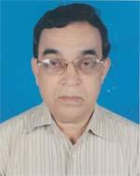 | DR. MD. KHALILUR RAHMAN  F/Name: Late Md. Suna Meah  M/Name: Late Amena Khatun  BM & DC Reg. No: 15657  NID: 1594115407240  Cell: 01731509454  Address: 193/1, Paikpara, Brahmanbaria  Blood Group: B+
168 | Voter No  LM-0700168 | DR. MD. REZAUL KARIM MOJUMDER  F/Name: Nurul Karim Mojumder  M/Name: Nurjahan Begum  BM & DC Reg. No: 53886  NID: 19861221303304197  Cell: 01717357951  Address: 535, Fulbaria, Brahmanbaria Sadar, Brahmanbaria  Blood Group: AB+
169 | Voter No  LM-0700169  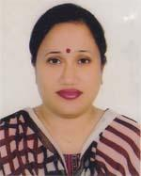 | DR. SHIBLI RANI DEBI  F/Name: Badal Chandra Nath  M/Name: Sabita Rani Debi  BM & DC Reg. No: 55578  NID: 1591904851578  Cell: 01747353414  Address: 303, 3nd Road, 557 kalaishree Para Kumarshil Moor B. Baria  Blood Group: B+
170 | Voter No  LM-0700170 | DR. NAFISA ALAM  F/Name: Jahangir Alam  M/Name: Monzu Man Ara Alam  BM & DC Reg. No: 4143  NID: 1221310361207  Cell: 01712391666  Address: House Name Matrichaya, Power House Road, Kandipara, Brahmanbaria  Blood Group: O+
171 | Voter No  LM-0700171 | DR. MOHAMMAD MOSHFAQUR RAHMAN  F/Name: Late A. K. M. Abu Sayed  M/Name: Late Rahena Khanom  BM & DC Reg. No: 35742  NID: 2696655302265  Cell: 01712169204  Address: Sadar Hospital, Brahmanbaria  Blood Group: B+
172 | Voter No  LM-0700172  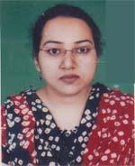 | DR. SHARMIN HAQ  F/Name: Md. Aminul Haq  M/Name: Kamrun Nahar  BM & DC Reg. No: 46108  NID: 2695435951226  Cell: 01712007919  Address: 250, Beded District Sadar Hospital, Brahmanbaria  Blood Group: B+
173 | Voter No  LM-0700173  No Image | ***NIL***  F/Name:  M/Name:  BM & DC Reg. No:  NID:  Cell:  Address:  Blood Group:
174 | Voter No  LM-0700174 | DR. KAMRUNNAHAR KALPONA  F/Name: Md. Abdul Quddus Molla  M/Name: Mrs. Azeda Begum  BM & DC Reg. No: 42330  NID: 3620205832706  Cell: 01935321847  Address: Mision House, Murail , B. Baria  Blood Group: B+
175 | Voter No  LM-0700175 | MD. RAKIBUL HASAN  F/Name: Late Eman Ali  M/Name: Jahanara Begum  BM & DC Reg. No: 39996  NID: 2690421386631  Cell: 01991911579  Address: Mission House, B. Baria  Blood Group: O+
176 | Voter No  LM-0700176 | DR. A. K. M. MUSTAKIM BILLAH  F/Name: Md. Abul Quasem  M/Name: Shah Parvin Akhter  BM & DC Reg. No: 63464  NID: 1594116381664  Cell: 01680671510  Address: 808, Shahibag, West Medda, Brahmanbaria  Blood Group: O+
177 | Voter No  LM-0700177 | DR. SUMAIYA BENTE JALIL  F/Name: Md. Abdul Jalil Khan  M/Name: Umma Salma  BM & DC Reg. No: 61166  NID: 4821108635964  Cell: 01677242837  Address: 28/A, Road No. -27, Dhanmondi, Dhaka  Blood Group: B+
178 | Voter No  LM-0700178 | DR. TANUSHRI ROY  F/Name: Mr. Manju Kanti Roy  M/Name: Mrs. Moni Rani Roy  BM & DC Reg. No: 64002  NID: 3620208532706  Cell: 01786668243  Address: Christian Memorial Hospital, Bonikpara, B. Baria  Blood Group: O+
179 | Voter No  LM-0700179 | DR. ARUNESWAR PAUL  F/Name: Mr. Biswes War Paul  M/Name: Mrs. Basanti Paul  BM & DC Reg. No: 60444  NID: 2617272869121  Cell: 01788577749  Address: Christian Memorial Hospital, Bonik para, B. Baria  Blood Group: O+
180 | Voter No  LM-0700180  No Image | ***NIL***  F/Name:  M/Name:  BM & DC Reg. No:  NID:  Cell:  Address:  Blood Group:
181 | Voter No  LM-0700181 | DR. MD. RAFIQUL BARI  F/Name: Late Md. Abdul Bari  M/Name: Mrs. Hasna Hena Begum  BM & DC Reg. No: 017728  NID: 1211350483703  Cell: 01711101676  Address: Bangladesh Gas fields Co. Ltd. Bira Shar, Brahman Baria-3400  Blood Group: B+

